**Market / Stocks / Currencies / News Portal**

One of the leading financial institution from LA Region wants to build a portal that displays wide variety of market information’s like Market Data, Stocks Data, Currencies Value, News in that region in near real time basis to their customers. At present the details are fetched from different sources and being maintained in an excel file which is difficult to manage, and most of the times becomes a stale data. And in addition, the human errors in maintaining these data also create a night mare to the team. To address this problem, the customer has come with a portal that collates these data from different trusted sources and provides the same in a composite format.

Data that needs to be fetched

|  |  |  |
| --- | --- | --- |
| Date Type | Processing | Data Sources |
| Currencies | The solution should maintain a configured % of cost to be added per currency  The value of the cost might be overridden for any special customers who has good relationship with the bank | <https://fixer.io/product>  <https://currencylayer.com/product>  <https://www.neutrinoapi.com/> |
| Stocks | Stocks infor | <https://finnhub.io/> |
| News | Display of news | <https://newsapi.org/pricing> |

The application developed should have following features :-

* User Login and Logout
* The System should implement push (server push) technology to deliver the data to the front end layer
* The system should apply required margin on the selected currencies
* The choice of displaying stocks by configuration or by user profile
* Google MD
* Responsive & Multi Layout Compatible
* The user can choose what data to view and manage
* The user can add some stocks or ccy pairs or news items to favourites bar
* Admin Users
  + able to setup users
  + able to setup the profit margin on the ccy pairs

**System High Level Diagram :-**

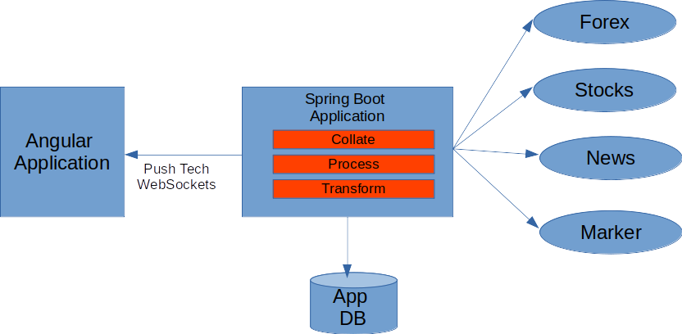

System Look and Feel :-

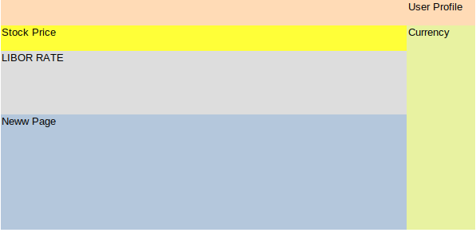

On Click of any stock details

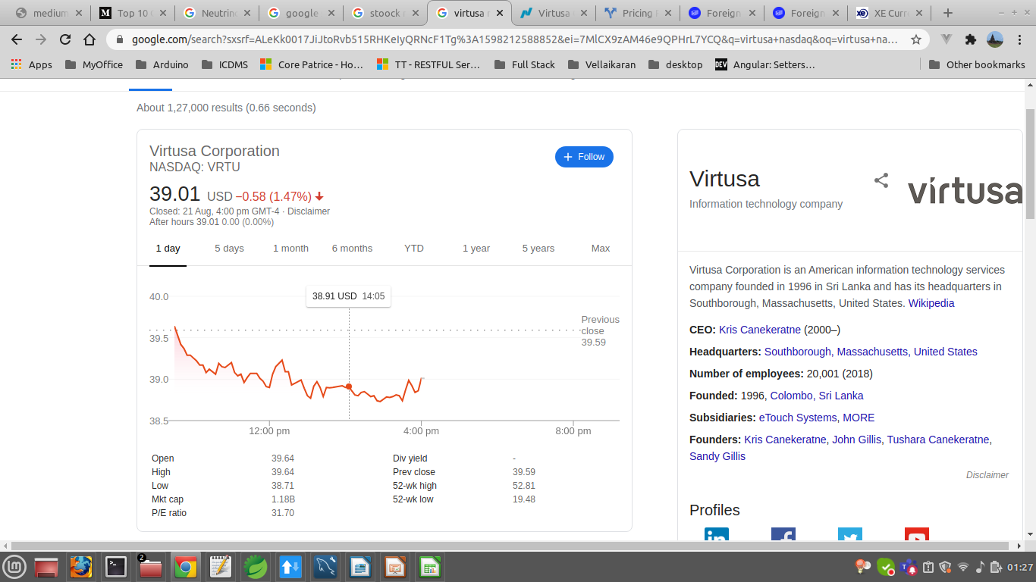

**Development Tools and Framework**

|  |  |
| --- | --- |
| Layer | Platform |
| Presentation Layer | React / Angular – Latest (w) Stomp/WebSocket/Observable/RxJS |
| BootStrap |
| Google MD |
| Yarn |
| Business Layer | Spring Boot , Stomp/WebSocket |
| Spring Security |
| Spring AOP |
| Spring Profiles/Properties |
| Spring Data JPA |
| Database | NoSQL - MongoDB |

**Non Functional Requirements:-**

|  |  |
| --- | --- |
| User Base | * Total Users – 100 * Concurrent Users – 50 |
| Number of Consumer application at any moment of time | Total Users – 1000  Concurrent Users - 250 |
| Throughput | 300 Transaction Per Second |
| Application Perforance | 2-3 Sec |
| API Performance | 1-2 Sec |
| Security | OAUTH2.0 (should align with Corp OAM/OID Setup) |
| UX | Responsive Application |
| Data Feed | 4 Seconds Sync, with server push technology |